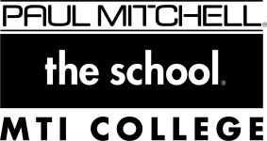

*This document is intended for internal use only*

Paul Mitchell Diploma Requirements

# Policy:

Once a future professional successfully completes all program requirements, their status in CampusVue will be changed to “Diploma” by the operations leader. The program requirements include:

* Completing the required hours of instruction as determined by the State of California
* Passing all theory exams
* Completing all assigned practical operationsand assessments

# Procedure:

* Upon completion of the required program hours, future professionals will meet with the program director or Education Leader to verify that all other program requirements have been completed.
* If all program requirements have been completed, the program director or Education Leader then directs the operations leader to update the future professional’s status in CampusVue to “Diploma” and close out their file for archiving.

Revised: 2/24/2020 Executive Committee Approval: 3/5/2020 Effective: 3/5/2020